Do real-time transit apps save time? Analyzing the impacts of transit real-time information on users waiting time

Luyu Liu

The Ohio State University

**Abstract:**

Real-time information (RTI) and Transit real-time information apps (RTI apps) have claimed to have significant impact on passengers’ waiting time and user experience. Although previous research thoroughly surveyed and simulated the overall impact on certain stops, few studies investigate the impact’s mechanism and its spatiotemporal pattern. In this paper, we first introduce several trip planning strategies (TPSs) for both RTI and non-RTI users’ incidence behavior and the concept of *volunteered optimization*. Then, with the support of GTFS real-time data, we optimize the RTI-based *prudent relaxation* TPS and calculate the waiting time for each TPSs. Moreover, we compare different TPSs to measure RTI’s waiting time reduction. The results prove that RTI apps using the optimized *prudent relaxation* TPS can decrease waiting time for some users, however, it shows great variation geographically and temporally and cannot achieve global optimality for all stops. It also shows that RTI apps using the *greedy relaxation* TPS will make users wait significantly longer than the bus delay, even longer than those who leave home randomly.

**Keywords:** Transit real-time information; GTFS; waiting time; mobile apps.

1. **Introduction**

Mobile technologies are changing people’s life in different ways, also for urban transportation and especially public transit. Real-time information (RTI) and transit RTI mobile apps are reshaping our way to use public transit (PT) systems. With all the benefits of PT system, many people still felt reluctant to take public transit. Numerous papers has proven that public transit users view the long waiting time as onerous (Algers, Hansen, & Tegner, 1975; Fan, Guthrie, & Levinson, 2016; Gkioulou, 2013; Larsen & Sunde, 2008; Reed, 1995), which is one of the topmost reasons discouraging people from using public transit.

Correspondingly, many research demonstrate that RTI and RTI apps can decrease users’ waiting time (citation). The rationale behind the reduction is: First, RTI apps can plan best time for users to leave for the public transit based on the walking time and PT timetable. Ideally, RTI apps can diminish the waiting time to 0, which means as soon as users arrive at the stop, the bus arrives and leaves. Besides scheduling based on static timetable, RTI apps adapt to PT system’s unreliability by providing users with actual bus arrival times at stops (Brakewood, Barbeau, & Watkins, 2014). For all PT system, delay is inevitable. When delay happens, RTI apps users can use their smart phone to get access to the real-time status of buses and plan their trips accordingly. With the help of RTI apps, users can have an anticipation about the on-time transit’s delay, thus minimize waiting time to better time their departure from home (or another trip origin) to a designated bus stop. Many RTI apps provide real-time trip planner to help users to schedule a best time to take public transit, such as Google Map and Transit.

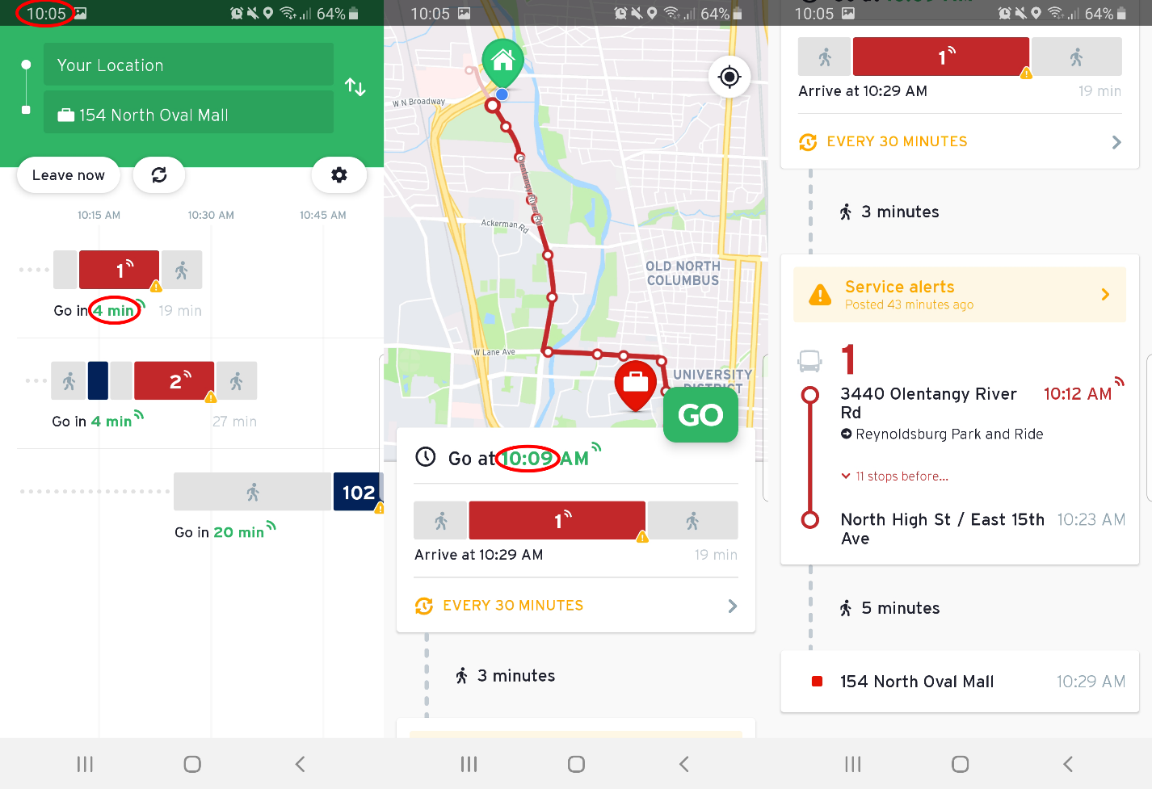

Figure 1 a typical interface of a real-time transit mobile app (Transit).

However, besides the benefit RTI apps produces, the RTI trip planning strategies can lead to several undesirable results. The optimization of waiting time also comes with high risk of missing a bus: during the time interval between when a person leaves their home and arrives at the stop, the actual arrival time of the bus may change. For example, if the bus is behind schedule, the driver may take opportunities to catch up the delay by speeding up. This means that a user may end up missing the bus since the RTI can become inaccurate during their travel from home to the bus stop, resulting in a much longer wait time. Paradoxically, the use of RTI may increase waiting times based on the actual performance of the public transit system and the time required to travel to the designated stop.

Nevertheless, even with more and more technology breakthroughs in this area, there are still economic and intellectual barriers for certain population to get access to the real-time public transit information. People who do not use smart phone application or do not own a smart phone cannot know the real-time status. These ordinary users have to plan their trips according to the schedule, their daily experience, or even random. Based on this fact, we would like to assess the average waiting time difference between non-RTI and RTI users and social justice issue behind the difference.

In this paper, we examine the impacts of RTI on public transit users’ waiting time based on empirical performance of a public transit system. We compare several trip planning strategies for deciding when to leave home to travel to the designated stop, including strategies that either ignore or exploit RTI. We assess and optimize different strategies’ waiting time and missed risk by consulting historical real-time bus feed. Based on the results, we compare non-RTI and RTI-based trip planning strategies. We also show how the performance of these strategies vary in different geographic and temporal level.

1. **Literature review**
   1. **Real-time big data in the public transit area**

The definition of *Big Data* is diverse under different circumstances and for different areas. A universally accepted definition can be generally categorized as five “V”: large volume, high variety, fast velocity, reliable veracity, and worthy value (Ayed, Halima, & Alimi, 2015; Chen, Mao, & Liu, 2014). The widespread application of affordable sensors as well as smart devices and rapid progress of information and communication technologies (ICTs) provide the technical support for the Big Data ; meanwhile, with more organizations, government institutions, and universities are embracing the concept of big data and open data policy, we are witnessing more and more data sources released into the public domain. Meanwhile, different data standard and specification partly solve

In the domain of the public transit, many data satisfy these standards

However, although this area is becoming more and more active, the majority of the papers are conceptual in nature, which lack empirical methodology (Chauhan, Agarwal, & Kar, 2016).

* 1. **Impact of real-time big data**

Analyzing the impacts of timely public transit information predates the development of contemporary real-time big data provided via webpages and smart phone apps. For example, Reed (1995) investigates signage and telephone’s real-time information’s impact on passengers’ waiting time. After the widespread application of smart personal devices, real-time information is becoming more accessible due to less expensive automated vehicle location system and the open data policy. Correspondingly, the body of literature is steadily growing and there are numerous studies investigating real-time information’s impact on public transit users (Brakewood et al., 2014; Brakewood, Macfarlane, & Watkins, 2015; Cats & Gkioulou, 2017; Ferris, Watkins, & Borning, 2010; Fries, Dunning, & Chowdhury, 2011; Liu, Shi, & Jian, 2017; Papangelis, Nelson, Sripada, & Beecroft, 2016; Watkins, Ferris, Borning, Rutherford, & Layton, 2011). We are going to review the literature based on two dimensions: information media and methodology.

**Information media.** We first categorize research according to their information media, including static signage, telephone and text services, and smart phone application. Signage and at-stop displays can provide PT users useful information and reduce actual and perceived wait time (Dziekan & Vermeulen, 2006; Reed, 1995). Moreover, at-stop displays’ psychological effect is even more important: systems showing the next train or bus’s departure time can greatly release anxiety (Dziekan & Vermeulen, 2006). However, users can only get arrival information at the stop; this limits its effectiveness beyond reassuring the user since the decision to leave the origin has already occurred.

Telephone service and text services are more useful than signage since people can get access to the real-time information before deciding to travel to the stop or station (Reed, 1995). However, the provision of real-time transit information via the World Wide Web and smartphone apps has made this information more accessible and useful. RTI apps provide users ability to comprehend the sophisticated timetable in a PT system, for both scheduled and real-time timetable. They provide both scheduled and real-time support for PT users with portable smart phone through user-friendly interface.

Many studies investigated the waiting time reduction by mobile real-time information, and the results are diverse: some concluded that RTI reduces the waiting time; while the others concluded that RTI’s impact on different users is not significant. For example, 91% percent of RTI users self-reported spending less waiting time in Seattle, 2010 (Ferris et al., 2010). Moreover, RTI users can save 2.4 minutes in Seattle, 2011 (Watkins et al., 2011) and 1.79 minutes in Tampa, 2014 (Brakewood et al., 2014) according to self-reported survey. Especially, in rural Scotland. RTI user can even save 7 minutes in average (Papangelis et al., 2016).

**Research methods.** Moreover, we can categorize research according to the research methods. These methods can be categorized into two main groups; survey-based methods and simulation models (Brakewood & Watkins, 2018).

Survey-based method is definitely the majority among all RTI impact studies. Survey-based methods include on-board surveys (Fan et al., 2016), before-after surveys (Chow, Block-Schachter, & Hickey, 2014), web-based surveys (Ferris et al., 2010), in-person surveys (Watkins et al., 2011), interviews and observations (Papangelis et al., 2016), and stated preference surveys (Liu et al., 2017). Surveys sample respondents with the same questions; they measure many variables, test hypotheses, and conclude temporal sequence from questions about past behavior, experiences, or characteristics (Neuman & Robson, 2014). Without the support of automatic real-time data, passenger surveys are the most direct methods to assess PT system use, especially for user experience and perceptions. Meanwhile, survey data can quantitatively assess different attributes using self-reported data (Neuman & Robson, 2014), which partially guarantees generalizability and authenticity. Besides, in contrast to the automatic generated data, the surveys’ data also point to users, instead of vehicles. The human-centered nature of survey data also guarantees its direct and close connection with human per se.

However, survey methods may not be suitable to solve other problems: survey-based studies investigate perceived or self-reported waiting time instead of actual waiting time. The perceived waiting time is different from the actual waiting time. For example, in Seattle, RTI users’ self-reported average perceived waiting time were 7.54 minutes compared to non-RTI users’ 9.86 minutes, while the average actual waiting time obtained by observers for RTI users is 9.23 minutes compared to non-RTI users’ 11.21 minutes (Watkins et al., 2011). Consequently, compared with value obtained by physical sensors or observers, the self-reported information may be biased by the users themselves.

Moreover, the survey’s size, especially for traditional data collection methods, is relatively small due to high cost of data collection (Goyder, 1986). On the other hand, some affordable methods are biased, especially IT (Information technology)-based methods. Mail survey (Rossi, Wright, & Anderson, 2013), text/phone call survey, and internet-based survey (Wright, 2005) can significantly reduce the time and economic cost of the survey. However, these methods face a same challenge: it is hard to access a representative sample (Rossi et al., 2013; Wright, 2005). For public transport system, not all users can get access to these IT-based services while the survey will only sample certain specific people.

Mathematical simulation is also often used to investigate and solve problems that are too difficult or costly to measure directly. For example, Cats & Gkioulou (2017) adopted an agent-based model to simulate the influence of PT reliability and real-time information on waiting time uncertainty. Agent-based model simulation usually adopts several assumptions and represents the simultaneous actions and interactions of various agents. The simulation tries to imitate and predict the performance of a complex system such as PT system (Gkioulou, 2013).

* 1. **Of real-time, within real-time, by real-time.**

Although the overall impact of the real-time data on waiting time was well explored, few studies investigated the variance of the impact (Brakewood & Watkins, 2018). Most studies investigated the overall average waiting time or perceived waiting time in certain areas; however, no one has investigated the variance of this impact relative to transit system’s on-time performance. The gaps include the waiting time’s distribution, spatial patterns, temporal patterns, and the mechanism of the impact.

Moreover, ironically, there are no studies using actual real-time transit data source due to the lack of easily accessible transit schedule and real-time vehicle location data, allowing the measurement and assessment of public transit delays at high spatial and temporal resolution. It is crucial to understand the real-time data by the real-time data per se:

The emergence of big data creates a precious chance to understand the real-time data per se and the manipulation process of it for the public transit authorities, RTI apps providers, and the passengers themselves. We would like to address these gaps of waiting time problem in the real-time transit context and implement it using the very same real-time transit data that the RTI apps are using.

1. **Methodology**

In this section, we first introduce the data source and corresponding manipulation processes. Moreover, we describe the synchronization process during the procedure of transit and the concept of *delay reclamation*. Based on the synchronization theory, we propose and model several trip planning strategies (TPSs) during the process of decision making and optimize the RTI apps user’s strategy based on deterministic real-time data. We also calculate the waiting time difference between RTI apps users’ deterministic process and non-RTI users’ probabilistic process.

* 1. **Data**

Introduced by Google in 2006, the General Transit Feed Specification (GTFS) consists of two data standards: GTFS static and GTFS real-time expansion. GTFS static indicates the schedule data of a PT system in several separate tables (Google Developers, 2016). GTFS static is the current *de facto* standard for PT system schedules and PT geographic information (Google Developers, 2016). As a standard for open data, it is easy to share and access for the public, open-source programmer, and researchers. For this paper, we collected and organized all history schedule data in MongoDB and Python environment from Application Programming Interface (API) provided by Central Ohio Transit Authority (COTA) bus system in Columbus, Ohio from February 2018 to February 2019.

Besides schedule data, GTFS real-time data provides vehicles’ geographic data with high temporal resolution. GTFS real-time includes two parts: buses’ location real-time data and the trip updates, which specifies the fluctuations in the real-time timetable (Google Developers, 2018). Unlike many traditional transit data, GTFS real-time data have large volume, high resolution, normalized standard, and full system coverage. For this study, we collected GTFS real-time data from API from COTA bus system with the frequency of 1 minute for more than 1 year.

* 1. **Synchronization**

Taking a bus could be conceptualized as a synchronization process between the walking trip to the target stop and the target bus’s *trip sequence array*. Trip sequence array is defined as the collection of trips running on the same route as the target bus in the direction of target bus.

Depending on user’s arrival time at the stop *t*, the actual bus that user will take can be different from the scheduled one. We use the same concept in the transfer synchronization process: *desynchronization degree* (DD), to measure the desynchronization between the bus and user at the stop. DD is an integer indicator that represent how many buses the user loses in the trip sequence array:

|  |  |  |
| --- | --- | --- |
|  | $$\begin{aligned}DD=\left\{\begin{aligned}0, \text{if actual bus is scheduled bus} \\ n, \text{if actual bus is }{\text{n}}_{\text{th}}\text{ after scheduled bus in the sequence array} \\ -n,\text{ if actual bus is }{\text{n}}_{\text{th}}\text{ before scheduled bus in the sequence array}\end{aligned}\right. \#\#\#\#\#\#\#\end{aligned}$$ | (1) |

It also means that if the user arrives at the stop between bus DD = n – 1 and bus DD = n, then the user will take bus DD = n.

The process of walking is linear: the users can control the walking time by selecting their home departure time (HDT). Except for very crowded conditions in dense cities, we can assume walking time is linear with respect to distance.

In contrast, the actual real-time performance of the bus is non-linear: the bus will not run at a fixed velocity and the expected time of arrival of bus at the stop is constantly changing. The vehicle operator can change the vehicle’s speed based on conditions in real-time. Most relevant to our question, a vehicle operator can make up for an initial delay by increasing speed. Indeed, public transit agencies value on-time performance and may incentivize drivers to compensate for delays when possible, considering speed limits and safety considerations.

We therefore introduce the concept of *reclaimed delay (RD).* Similar to delay propagation (Park, Mount, Liu, Xiao, & Miller, 2019), it is the time difference between the actual time of departure (ATD) and the expected time of departure (ETD) at the stop. It also represents the delay that the bus catches up between two stops.

|  |  |  |
| --- | --- | --- |
|  | $$RD\left(t, i\right)={ETD}_{i, t}-{ATD}_{i}, i∈S$$ | (2) |

Where: S is the collection of stops on the route, i is the target stop, t is the current time.

Figure 2 shows corresponding space-time diagram of the expected synchronization, the actual desynchronization, and delay reclamation process. After the user leaves home, the actual bus trip (blue line) will diverge from the expected bus trip (red line) and converge with the scheduled bus trip (yellow line): since the bus has an initial delay near the user’s home, the bus accelerates and catches up the delay with the schedule. However, the user’s walking trip is still aiming for the expected bus trip. Consequently, the bus arrives earlier than the user’s expected time and the user will miss the bus.

The reclaimed delay could be small but critical for RTI apps users: consequently, the RTI apps user will lose the bus and suffer waiting time penalty for a relatively long time. Thus, the synchronization of these two processes is highly unstable. Besides the delay reclamation mechanism, inaccurate geographic locations and delays in updates due to internet congestion and failures may also contribute to the desynchronization.

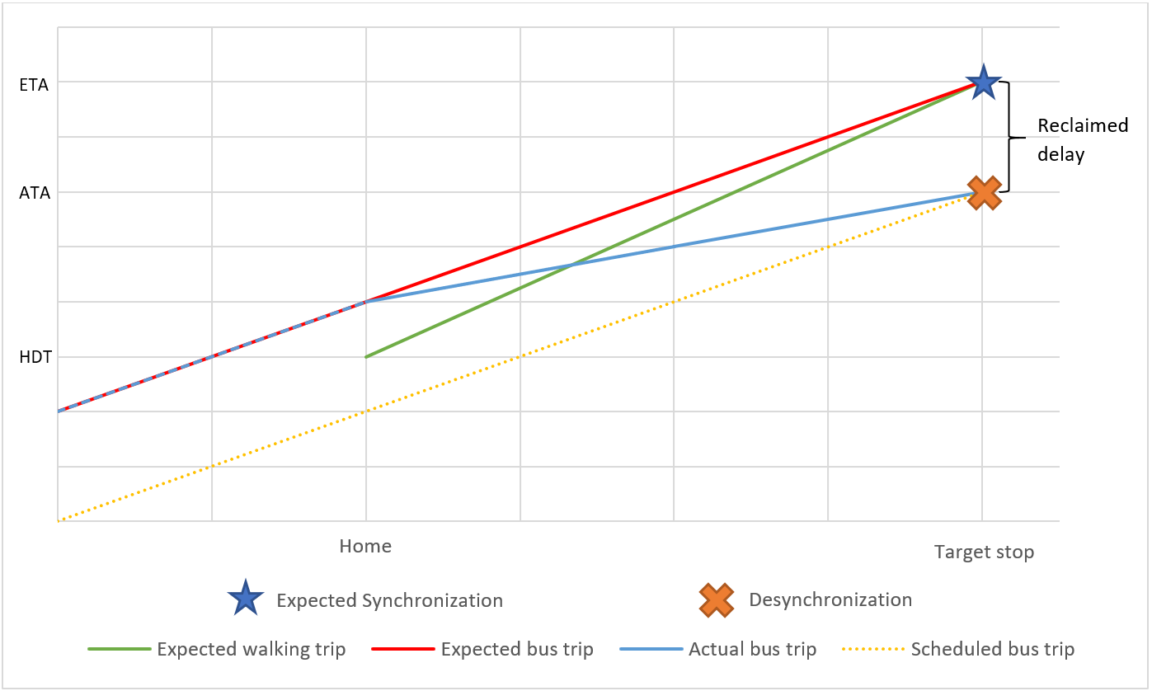

Figure 2 space-time diagram of the expected synchronization and the actual desynchronization

Besides reclaimed delay, due to the discrete nature of the real-time information data, there are a *discontinuity delay* for all RTI-based trip planning strategies as shown in Figure 3: if RTI apps do not interpolate the void between the data feeds and their corresponding timestamp, the RTI-based users and especially GR users will wait until the data is updated. However, when the data is updated, the GR user is already late for the bus. Similarly, if the user decides to leave between two updates, although the RTI apps will show the good result based on the last update, in reality the user will miss the bus if she/he were shown the actual position of the bus. Either scenario is the consequence of discontinuity of the real-time data. Exactly like reclaimed delay, although the discontinuity delay could be very small in value, it still can results in desynchronization and significantly long waiting time.

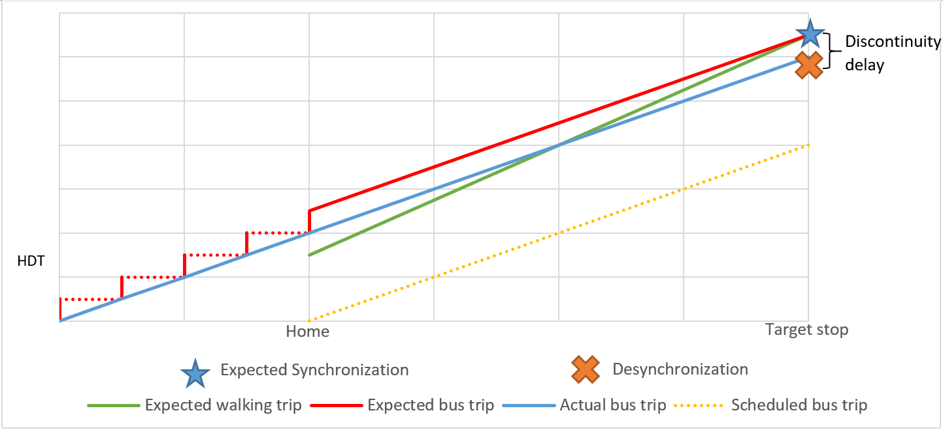

Figure 3 the discontinuity delay of real-time data

* 1. **Trip planning strategies**

A trip planning strategy (TPS) can be interpreted as a tactic for a user to plan and execute the transit trip. Assuming no disturbance on user’s walking and boarding process, different TPS has only one controllable factor to determine the actual waiting time: the time to leave home for the transit (home departure time, HDT). RTI apps relaxes the fixed timetable in a frequently delayed PT system, thus saving waiting time for RTI apps users. Depending on how to determine the home departure time, there are different trip planning strategies for both RTI apps and non-RTI users and their different purposes. Since we have access to the buses’ real-time information, if the home departure time is given explicitly, the calculation of TPSs’ real-time performance is deterministic.

**[Non-RTI trip planning strategies]**

In traditional incidence behavior studies, users are divided into two groups: timetable-independent passengers, who are not aware of the system schedule and performance, and timetable-dependent passengers, who are aware of the system schedule or empirical performance (Frumin & Zhao, 2012). These two user groups are introduced in the context of non-RTI experience. Here, we moreover divide non-RTI users into three groups.

**Arbitrary tactic (AR)**. Before the time of smart phone, text, and public real-time information, under many circumstances, PT users were not necessarily planning their trips. A simple strategy is to walk to the stop and catch the subsequent bus arbitrarily. The major assumption is that the user’s arrival time is independent from the vehicle system (Frumin & Zhao, 2012). For the same reason, these users are also considered timetable-independent.

Because the user’s decision-making process is random, it is reasonable to assume user’s HDT or user’s arrival time is evenly distributed among the headway between two buses. Traditionally, the average waiting time is the expectation of the random variable headway (Frumin & Zhao, 2012) (see Appendix A). However, since we have access to the real-time vehicle departure time data, we can calculate the empirical average waiting time as the mean of the departure time of target bus and its subsequent bus. Thus, the users’ home departure time is:

|  |  |  |
| --- | --- | --- |
|  | $$t_{hd}=T_{middle}-δt_{w}=\frac{1}{2}⋅\left(T_{DD=-1}^{'}+T\right)-δt_{w}$$ | (3) |

Where: $T_{middle}$ is the median of the target bus and its subsequent bus and $δt_{w}$ is the walking time. $T$ is the bus’s actual real-time departure and $T_{DD=-1}^{'}$ is the very first prior bus’s actual real-time departure time.

Theoretically, this strategy is not very efficient. The rationale behind the calculation is that we can make it a good benchmark: if another TPS’s performance is even worse than AR, we can say that it is not effective.

**Null relaxation (NR)**. Without knowing any information about the running status, users can still follow the schedule published to the public in advance. Traditionally known as timetable-dependent users, NR users prefer earlier final arrival time than convenience. Under this circumstance, the user will follow the scheduled timetable of the PT system regardless of waiting time. Consequently, the RTI apps user will not benefit from waiting time reduction. However, since theoretically no bus/train will leave earlier than the scheduled time, NR minimizes the missing risk. NR is another benchmark for all TPSs, which theoretically has the lowest missing risk.

**Empirical relaxation (ER**). If a user can get access to the historical information on system performance, either from daily experience or a database, the user can relax the HDT based on the empirical average time/maximum time without any RTI.

For the derivation of $\overline{T}$, different users may adopt different ER strategy. In general, there are two parameters to determine an empirical HDT: learning function and learning memory. Learning function means the rules to generate the historical information, such as averaging and minimizing. Learning memory is the available time period for the learning process. Ordinary users will not memorize all the historical information due to limited memory and limited access to the historical data.

|  |  |  |
| --- | --- | --- |
|  | $$t_{hd}=\overline{T}-δt_{w}=\min_{n}{T_{i}}-δt_{w}$$ | (5) |

where: $\overline{T}$ is the user’s empirical arrival time for the bus trip $.$ $T_{i}$ is the bus trip’s actual departure time on day *i*, and n is the learning memory (days). This specific ER strategy’s learning function is minimizing and its learning memory is n days.

ER is a common non-RTI strategy. In this paper, we also investigate waiting time’s relationship with ER strategy’s learning function (averaging and minimizing) and learning memory (1 days – 10 days). Based on the results, we will find an ER strategy with the smallest average waiting time.

[**RTI-based trip planning strategies]**

To investigate the RTI-user’s behaviors, we need to first conceptualize the RTI apps’ trip planning process. Most RTI apps will directly use the ETDs provided by GTFS trip update for the buses’ real-time information (Google Developers, 2018; Transit app, 2019). The process of RTI apps’ decision making consists of several steps: First, RTI apps will provide different path choices for users and their HDT or users will find the desired bus trips/routes from the list in the RTI app. Then, the trip update data will provide ETDs at the target stops for RTI apps or users. Finally, RTI apps or users will subtract estimate walking time and obtain estimated HDT. The estimated HDT is not constant; instead, RTI apps will update it according to the real-time trip update data.

Previous research has proven that RTI users will adapt their behavior to shorten their waiting times (Cats & Gkioulou, 2017). Depending on the relationship between given estimated HDTs and the current time, the user will decide the actual HDT. Just like non-RTI strategies, the essential part is the criteria to derive the actual HDT.

**Greedy relaxation (GR)**. Most transit users do not want to wait. Moreover, if a user encounters extreme weather events, especially cold weather and heavy precipitation, she/he may want to reduce the waiting time as much as possible. In practice, a greedy relaxation (GR) user will check the relationship between suggested HDT and current time by consulting RTI apps. She/he will only leave if the RTI app tells her/him so according to the real-time data, when the bus’s ETD at the stop is equal to or greater than walking time plus current time:

|  |  |  |
| --- | --- | --- |
|  | $$t_{hd}=t_{cu}, if t_{cu}+δt_{w}≥T_{ex}$$ | (6) |

Where: $T_{ex}$ is the scheduled bus’s ETD at the stop given by RTI app and real-time data, and $t_{cu}$ is the current time when $t_{cu}+δt_{w}≥T_{ex}$.

This strategy can achieve temporary optima as shown in Figure 2 as the green line. However, due to the instability of PT system, the missing risk of GR is also the highest. Due to the possible reclaimed delay and discontinuity delay, the bus will likely leave earlier than ETD. Even a smallest disturbance during the walking process or the bus running status during user’s walking can result in a missing bus using this strategy. Consequently, the user may suffer from a long waiting time penalty, which is almost equal to a headway, the largest possible waiting time.

**Prudent relaxation (PR)**. Figure 2 and Figure 3 together show the high risk of GR trip planning strategy. If a user would like to save waiting time and keep some degree of missing risk simultaneously, she/he may leave a short buffer of several minutes earlier than GR. Similar strategies were adopted in the context of scheduled time: some passengers will leave 2-3 minutes before scheduled service arrival in case of some unexpected “risky” events, such as delay by the elevators (Fonzone, Schmöcker, & Liu, 2015). These risk aversion reactions are usually defined as costs of unreliability (Frumin & Zhao, 2012).

Similarly, a prudent RTI passenger will leave a short buffer for the risk of missing bus and unexpected reclaimed delay and discontinuity delay. This short time buffer, which is defined as *insurance buffer* (IB), trades some time to reduce missing risk, thus decreasing instability of the buses’ real-time performance. PR users’ HDT is:

|  |  |  |
| --- | --- | --- |
|  | $$t_{hd}=t_{cu}, if t_{cu}+δt_{w}+IB≥T_{ex}$$ | (7) |

where: IB is the insurance buffer.

The buffer strategy is a combination of empirical and real-time result: the calculation of buffer is empirical, and the calculation of actual home departure time is based on the empirical buffer and real-time information. Figure 4 also suggests the relationship between IB and reclaimed delay. RTI-based strategy is risky due to the existence of reclaimed delay, thus, the ultimate purpose of IB is to compensate for the reclaimed delay. Therefore, in the theoretical optimal PR scenario, an optimal insurance buffer should be exactly equal to the reclaimed delay to achieve 0 waiting time. Practically, IB can also relax the instability caused by the discontinuity nature of RTI feeds and some measurement errors.

Insurance buffer’s value is also a good indicator of the transit users’ risk attitude: It represents how much time the user is willing to gamble to gain the waiting time reduction. We define two extreme values of risk attitude: *risk-seeking* and *risk-averse*. *Risk-seeking* means the user would rather seek for the waiting time reduction regardless of the potential missed risk, which will possibly incur an additional large waiting time caused by desynchronization; *risk-averse* means the user would rather wait more time to avoid desynchronization. The less IB’s value is, the more risk-seeking and less risk-averse the user is.

PR and GR can be categorized as a PR family, for GR is a special case of PR with IB = 0. With different IBs, each PR strategy can vary in actual waiting time. We would like to optimize IBs and find the best PR strategy with maximal waiting time reduction.

**Prudent relaxation with optimal insurance buffer (PR optimal)**. Previous research concentrated on PT system’s optimization in the stage of planning and operation. Due to the lack of authority and information access, ordinary users were rarely considered as a part of optimization process. However, with RTI, although users still cannot directly improve the real-time systematic performance (delay, ridership) of the system per se, optimization can be conducted in the individual level to reduce waiting time.

Correspondingly, we introduce the concept of volunteered optimization: despite PT systems’ instability and uncertainty, users with appropriate RTI advice can adapt and optimize each trip according to the delay and real-time information. Volunteered optimization is independent from the scheduled timetable; instead, it is based on the real-time status and decentralized. The RTI apps or the public transit service providers will pre-calculate all the optimal parameters; users will consult the suggested home departure time and leave home accordingly. In this way, with the maximization of waiting time reduction in the individual level, the overall waiting time penalty will also be diminished. To achieve volunteered optimization, it is necessary to optimize each individual trip, which is from PR strategy family. Correspondingly, we need to find the PR strategy with optimal insurance buffer: *PR optimal*.

Figure 4 shows the how PR optimal resynchronizes with the actual bus trip. Instead of the expected walking trip (shown as green solid line), the PR optimal user will follow the RTI apps’ pre-calculated optimal plan with insurance buffer (shown as green dash line). Due to the existence of insurance buffer, the reclaimed delay is therefore offset and the user will successfully take the expected bus.

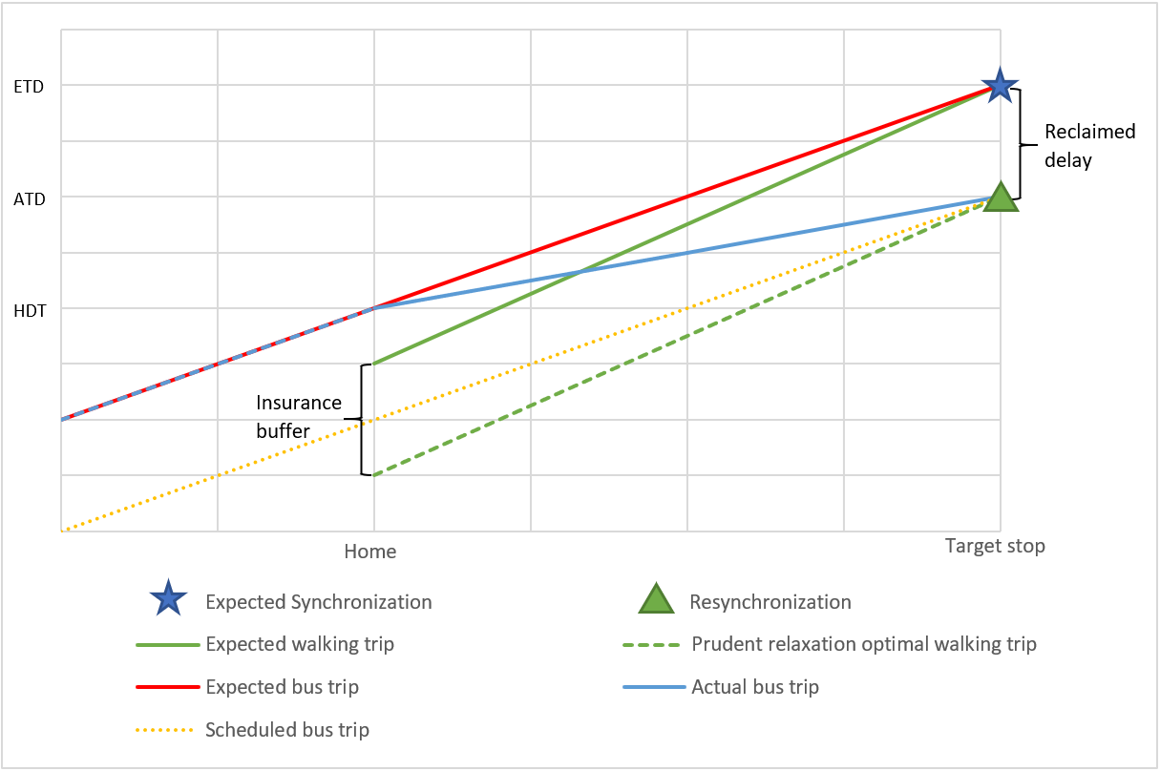

Figure Space-time diagram of the PR optimal's trip

For PR or GR TPS, the users will plan their HDT according to the bus’s ETD instead of the real departure time. Here we define expected waiting time:

|  |  |  |
| --- | --- | --- |
|  | $$δt^{'}=T_{ex}\left(t\right)-t=T_{ex}\left(t\right)-t_{hd}^{PR}-δt_{w}$$ | (8) |

where: $T_{ex}\left(t\right)$ is the ETD, t is the user’s arrival time at the stop, $t_{hd}^{PR}$ is PR strategy’s HDT, and $δt_{w}$ is the walking time.

Combining (9) and (8), we have:

|  |  |  |
| --- | --- | --- |
|  | $$δt^{'}=IB$$ | (9) |

For PR family, the expected waiting time is equal to the insurance buffer.

To find the $PR_{optimal}$, empirically, we simulated the users’ real-time waiting time using different IB. Figure 5 is the flow chart of PR optimization. There are four major steps in the learning process:

* Calculation: Calculate the performance for all designated buffers for optimization (0 – 290 seconds). The results contain user’s arrival time at the stop and the actual taken bus’s departure time for users with different walking time (0– 9 minutes).
* Optimization: Find the smallest waiting time and the corresponding buffer each day. If there are multiple smallest waiting time, designate the one with smaller buffer.
* Finalization: For each day, reduce all past days’ buffers into one by finding the maximum of the optimal buffers. Meanwhile, to accommodate the seasonal major changes in the schedule, we will restart the learning process whenever the major change is facilitated.
* Revalidation: Based on the finalized buffers, calculate the performance of each day.

All of the steps can be conducted by RTI apps or transit providers in the operational stage on the fly. In this way, we guarantee the optimality of obtained buffers: first, *calculation step* and *optimization step* guarantees that obtained buffers in each day have the least waiting time; second, *optimization step* guarantees that obtained buffers are the smallest one among the buffers with the least waiting time; third, *finalization step* guarantees that trips with finalized buffers are most synchronized for each day when revalidating the performance. In the sense of risk attitude, we adopted a *risk-neutral* strategy: we want to find the smallest buffers while trying to keep synchronized for most trips; in the sense of model fitting, we want to find the balanced fitting status between overfitting and underfitting.

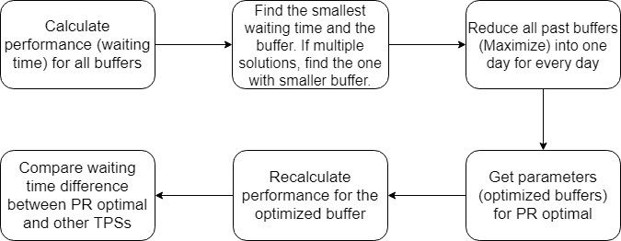

Figure 5 Flow chart of PR optimization algorithm

For the first dominating step of the optimization process, the computation complexity is $O(b⋅d⋅t⋅s⋅w⋅n)$, where b is the number of possible buffers, d is the number of dates, t is the number of GTFS trips, s is the number of stops in a trip, w is the number of walking time, n is the number of the GTFS feeds for the stop. Thus, the total complexity is polynomial and of high power. The optimization process of $PR_{optimal}$ produces massive number of parameters $IB_{ijk}$. We minimized waiting time over $IB_{ijk}$, which will have a different IB for each day, each trip, each stop, and each walking time.

In practical, to reduce computation load, we selected bus route No. 2 as our research target. Bus route No. 2 is a major route with large spatial and temporal coverage and ridership in the COTA bus system. We calculated the performance for every stop on COTA bus route No. 2 for different IBs, from 0 to 300 seconds with interval of 10 seconds. We also parallelized the outmost loops (buffers × dates) to improve computation performance on a workstation with 40 virtual CPU cores.

* 1. **Measures**

We would like to measure the difference of waiting time and risk of missing a bus/train between the RTI users and non-RTI users. Therefore, we define two measures: the missing risk and average waiting time.

**Missed bus risk.** The missed bus risk measures the probability of missing a bus based on the TPS relative to the actual performance of the transit system:

|  |  |  |
| --- | --- | --- |
|  | $$Risk=E\left(a_{i}\right)=\frac{1}{n}\sum_{i=1}^{n}{a_{i}}$$ | (10) |

Where: n is total number of trips; $a_{i}=\left\{\begin{aligned}1, \text{if DD>0} \\ 0, \text{otherwise}\end{aligned}\right.$

Here we define missing a bus/train as: the actual bus’s desynchronization degree is larger than 0. This also means the user takes a different bus after the scheduled bus.

**Average waiting time**. Average waiting time measures the expected wait time across all trips based on the TPS. We start by defining the actual wait time:

|  |  |  |
| --- | --- | --- |
|  | $$δt=T_{r}\left(t\right)-t=T_{r}\left(t\right)-\left(t_{hd}+{δt}_{w}\right)=f\left(t,T_{-M},…, T_{n},… , T_{N}\right)-\left(t_{hd}+{δt}_{w}\right)=T_{n}-\left(t_{hd}+{δt}_{w}\right), if T_{n-1}≤t<T_{n}$$ | (11) |

Where: $δt$ is the actual waiting time, $T_{r}(t)$ is the bus’s actual real-time departure time, and $t$ is user’s arrival time at the stop. $t_{hd}$ is user’s HDT, and $δt_{w}$ is user’s walking time from home to the stop. Equation 11 also proves that the only factor that user can control and can affect waiting time is $t_{hd}$, based on a static walking time.

The mathematical expectation of waiting time’s distribution across all trips is the average waiting time:

|  |  |  |
| --- | --- | --- |
|  | $$AWT=E\left(δt_{i}\right)=\frac{1}{n}\sum_{i=1}^{n}{δt_{i}}$$ | (12) |

where: n is total number of trips.

* 1. **Implementation**

We collected GTFS real-time trip update data and corresponding GTFS static schedule data of the COTA (Central Ohio Transit Authority) bus system in Columbus, Ohio from January 2018. The data is stored in a MongoDB database. The GTFS trip update contains the ETD and ATD for every stop and every minute. We developed the algorithm in Python environment and maintained our smart transit database. We constructed a generic GTFS real-time database with more than 300 GiB volume in MongoDB and also generated other auxiliary databases in terabyte level in total. We simulated the calculation and optimization process of RTI apps and user’s trip planning process by calculating the walking distance between the user and the target stop.

With the support of MongoDB databases, we moreover developed a web-map visualization interface using JavaScript and Leaflet. The web-based geographic information system can be generalized and expanded into any PT systems with GTFS real-time support.

1. **Analysis**

In this section, we focus on the geographic and temporal analysis of buffer, waiting time, and waiting time difference between different TPSs. For the study area and target, we choose COTA bus No. 2 from Southeast to Northwest from Feb 2018 to Feb 2019. The bus route has two schedules: the frequent one originates from red circled stop (frequent originating stop) in Figure 6 with headway of 10 – 15 minutes, while the standard on originate from blue circled stop (standard originating stop) in Figure 13 with headway of 20 – 30 minutes (COTA, 2019).

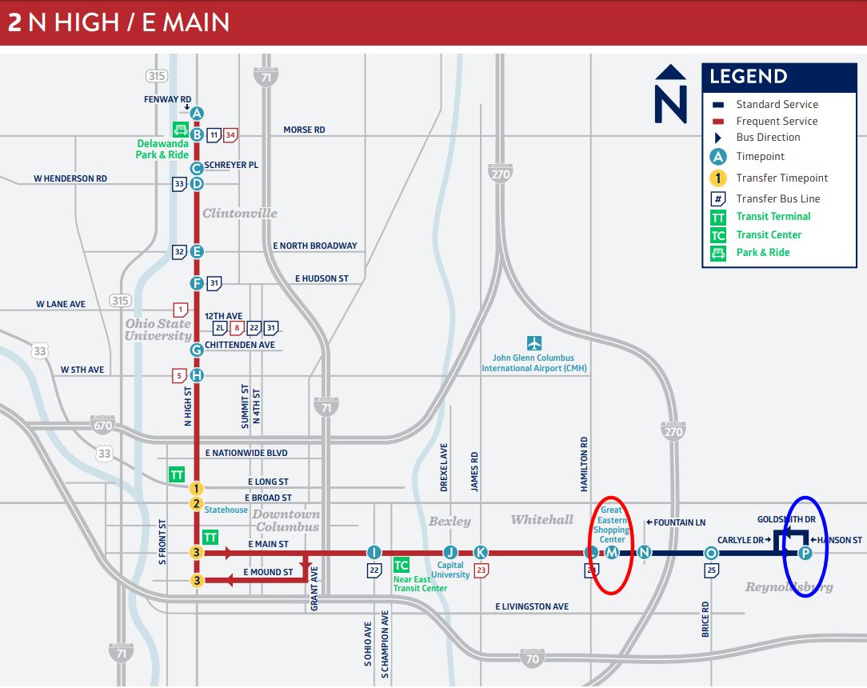

Figure Bus route 2's standard and frequent service map (COTA, 2019).

|  |  |  |  |  |
| --- | --- | --- | --- | --- |
| TPS | Average waiting time Mean | Average waiting time deviation | Risk Mean | Risk Deviation |
| NR | 224 seconds | 290 seconds | 3.72% | 18.93% |
| PR optimal | 226 seconds | 326 seconds | 8.31% | 13.90% |
| ER with memory | 291 seconds | 480 seconds | 14.89% | 35.40% |
| AR | 509 seconds | 327 seconds | - | - |
| GR | 620 seconds | 683 seconds | 62.10% | 62.40% |

Table Each TPS's waiting time and missed risk's mean and deviation

Table 1 shows themean and deviation of each TPS’s waiting time and missed risk. In general, NR and PR optimal’s average waiting time is equally the smallest. Also, due to larger variation, in some area and time PR optimal can be especially more effective.

ER family and ER with memory (6) are less effective: in average, an ER user has to wait almost 1 minutes longer than an NR user. Meanwhile, despite as a member of PR family, GR’s performance is very poor. Its average waiting time is even longer than the random AR. The terrible performance is due to its high missed risk.

Moreover, in the sense of risk attitude, NR optimal is the most risk-averse TPS, since the user is willing to avoid desynchronization with longer expected waiting time. As opposed to NR optimal, GR is the most risk-seeking TPS, since the user leaves no insurance to seek for the maximal expected waiting time reduction. PR optimal, otherwise, can be regarded as a balance point between the two polar, which can be called *risk-neutral* TPS.

* 1. Geographic pattern

**Arbitrary relaxation**

Arbitrary relaxation has an average waiting time of half of the headway. Therefore, we can observe a drastic change between standard schedule and frequent schedule due to the increase of headway in Figure 14 (top right). Intuitively, the performance of AR should have been the worst among the TPSs. However, greedy relaxation, as the only RTI-based TPS, has the worst waiting time of 620 seconds compared to AR’s 509 seconds. This also proves that RTI users without proper advice could wait significantly longer than even arbitrary relaxation.

**Null relaxation**

Theoretically, NR user’s waiting time is exactly the delay of the bus they take since the buses’ actual departure should be always later than the scheduled time. In other terms, the theoretical missed risk is always 0. However, the reality is sometimes otherwise, NR’s actual missed risk is 3.72%. The average waiting time starts from 0 while it accumulates and propagates along the route with fluctuations, as shown in Figure 14 (bottom right), just as the delay.

**Empirical relaxation**

In this section, we validate each ER TPS with settings selected from 2 learning functions and 9 learning memories. Figure 7 visualizes the waiting time of 18 ER family TPSs. Two curves start at a same point, since averaging and minimizing are the same with the memory of 1. For minimizing learning function, the waiting time will increase with negative acceleration along with increasing learning memory; for averaging learning function, the waiting time will decrease with increasing acceleration along with increasing learning memory. Minimizing also have a U-shape curve that waiting time is the smallest when memory period is 6. It proves that minimizing’s performance is much better than averaging’s and we conclude that ER TPS with minimizing and memory = 6 is the best ER among the others.

Figure the waiting time of ER family with minimizing and averaging learning function and 1 – 9 learning memories

Meanwhile, as a non-RTI TPS, ER with memory does not outperform the RTI-based PR optimal. It also strengthens a simple intuitive assumption: real-time information helps, somewhat.

**Greedy relaxation**

Figure 14 (top left) shows the graphic pattern of GR’s waiting time and Figure 15 (top right) missed risk. Ironically, as a TPS exploiting RTI, GR’s performance is the worst: it cannot even outperform arbitrary relaxation. The primary reason is the high missed risk. Despite the shortest expected waiting time, due to delay reclamation and discrete real-time data feed, GR users have the largest missed risk thus the longest waiting time.

As a member of PR family, GR’s waiting time’s pattern also has the contour lines and walking time difference. Figure 11 and Figure 12 show GR’s waiting time and missed risk’s relationship with walking time. For GR, due to its high missed risk, longer walking distance larger than 120 seconds will in fact improve its performance. The fact that missed risk is initially at a high level makes longer walking time a similar role as insurance buffer: longer walking time will destabilize the synchronization process and make more GR’s desynchronized trips synchronized again.

The inefficiency of GR also proves the correctness of synchronization and delay reclamation process in Figure 2 and the discontinuity delay in Figure 3. To moreover show the relationship between reclaimed delay, discontinuity delay and miss risk, we also calculate the delay reclamation and miss risk for each specific trip. We summarized that during the whole year, when a delay reclamation occurred, there were 85.20% chance that the GR user would miss the bus empirically. However, delay reclamation only accounted for 22.88% of GR users’ desynchronization: due to the existence of discontinuity delay and random error, GR users may consequently get the late update and miss the bus.

To understand this phenomenon, we calculated 31 TPSs in the PR family, each with a uniform insurance buffer for all trips and all stops from 0 (GR) to 300 seconds. Figure 8 and Figure 9 respectively show the average waiting time and the miss risk change with the uniform insurance buffer. Each graph of changing rate shows clear discrete pattern: there were several sudden changes for each indicator’s changing rate at 60, 120, 180, and 240 seconds, which are all multiples of the interval of the real-time data (60 seconds). The points between these sudden changes are relatively close, forming a stepped curve. Moreover, Figure 9 demonstrates that the miss risk changed fastest when buffer = 60 seconds, which is exactly the interval of the real-time data.

The buffer will ease both reclaimed delay and discontinuity delay simultaneously, however, due to the discrete nature of discontinuity delay, only multiples of 60 seconds will we observe the sudden change of discontinuity.

Figure 8 average waiting time and average waiting time changing rates' relationship with uniform buffer.

Figure 9 miss risk and miss risk changing rate's relationship with uniform buffer.

**Prudent relaxation optimal**

We first calculated and analyzed the optimal insurance buffer (IB) for prudent relaxation optimal strategy. Figure 10 (left) shows the geographic distribution of PR optimal’s insurance buffer. It shows an extreme geographically diverse pattern for IBs. As a result, we should not assign a single IB for all stops and different users with different walking distance. Based on the results, we validate the PR optimal and investigate its geographic patterns from three directions.

[Vertical – Marginalized stops]

Figure 10 (left) shows PR optimal’s average waiting time on COTA bus route No.2 from Southeast to Northwest. Noticeably, there are two significant high clusters near the two originating stops (red circled and blue circled) in the standard and frequent No.2 bus schedule. Figure 15 (top left) demonstrates the missed risk for the PR optimal strategy, and it also shows two unnatural high missed risk cluster near the two originating stops.

This is because the lack of real-time data in the very beginning of bus trips. The real-time information will not be available until the bus leaves the originating stop. Also, sometimes the data will not be updated promptly because the data’s update frequency is 30 seconds. For certain trips, by the time the real-time information is updated, the user already loses the bus. Under this circumstance, buffer will not help improve the missed risk of such trips since IB’s effectiveness depends on accessible real-time information. Meanwhile, users who live far from the stop will have higher missed risk and will consequently suffer from even more waiting time.

Out of the two high clusters, the standard originating stop (blue circled) has higher waiting time. The headway near the standard originating stop (red circled) are larger in the bus schedule. Both the high missed risk and large headways contribute to the unnatural long waiting time at the standard originating stop (blue circled) compared to the frequent originating stop (red circled).

Based on these facts, we can call these stops *marginalized stops*. It suggests that RTI strategies may be less effective at these stops. In these areas, public transit users are vulnerable and constantly given misled information.

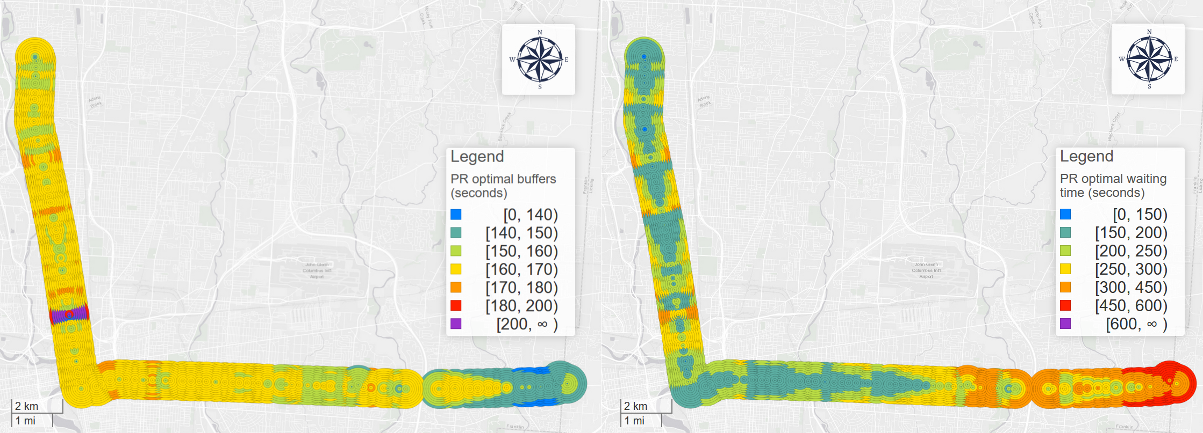

Figure PR optimal’s insurance buffer for each stop and average waiting time in COTA bus route No. 2 from Southeast to Northwest in 2018.

[Diagonal – Contour lines]

An obvious diagonal pattern that can be observed in the map is the parallel diagonal contour lines. In the map, for each point on the contour line, their values are almost the same. Most maps above prove the presence of the contour lines. We can conceptualize the contour lines in a smaller scale: two neighboring circles at two subsequent stops with the same value. It is the smallest unit of the contour line. These two circles’ walking time difference is nearly equal to the bus’s running time between the two stops. With more neighboring circles with the same value, the contour lines are formed.

There are two reasons for this phenomenon. First, for the two neighboring circles, essentially these users in the two areas are aiming for the same bus but at different bus stops; second and most importantly, users in the two areas will get a same real-time data simultaneously and plan their trips according to the same data feed, thus arrive at the target stop at the same time. Therefore, if no disturbance or acceleration between the two stops, the two trips are the same, only with different walking distance. This also suggests that the gaps on the maps are the point where delay oscillates, and the bus is running in the constant speed in the areas with smooth contour lines. The contour lines’ formation can also be understood in another temporal sense: after the bus receives a disturbance at a stop, the disturbance will persist and spread outwards when the bus is moving to following stops.

[Horizontal – Walking time]

Figure 8 illustrates the relationship between waiting time and walking time and Figure 9 shows the relationship between missed risk and walking time. For PR optimal, the longer walking time is, the longer will the user wait and the riskier the user will be to miss the bus. This supports the claim that the longer distance the user lives from the stop, the more unstable their trip becomes. During the longer walking time to the stop, the bus could be more likely to accelerate to catch up the delay, making RTI users miss the target bus.

Figure 11 PR optimal, GR, AR, ER, and NR’s waiting time's relationship with the walking time

Figure 12 PR optimal, GR, ER, and NR’s missed risk's relationship with the walking time

[Difference between NR and PR optimal]

Figure 13 (right) shows the average waiting time difference between NR and PR optimal on COTA bus route No. 2 from Southeast to Northwest. The differences represent the distinction between performance of best non-RTI users (NR) and best RTI users (PR optimal), respectively. We can observe that PR optimal does not outperform NR for all stops. In fact, for most stops, especially for those stops in the upstream near the originating stops, NR’s performance is much better than PR optimal.

For PR optimal which is independent from the schedule, we can observe a relatively less oscillating pattern for all stops, expect the originating stops with exceptional high waiting time. For most stops, waiting time keeps a relatively low level, but we can hardly observe a stop with an even lower waiting time. This is because IB reduces desynchronization risk when the user catches the bus, but it also makes people wait more time for these synchronized trips. In conclusion, too large (risk-averse) or too small (risk-seeking) buffers all impair the effectiveness of PR optimal, but too small buffers will especially result in desynchronization and suffer more waiting time.

Consequently, due to PR optimal’s relatively large waiting time in the upstream stops, NR users will wait less than PR optimal users. On the other hand, for areas with significant delays, PR optimal will outperform NR.

The comparison moreover proves that PR optimal cannot achieve absolute optimality, instead, the upstream and downstream stops show polarized patterns. We could see this in Table 1: although PR optimal’s average waiting time is larger than NR’s, the variation of PR optimal is exceptionally large. To moreover prove the variation, we divide the stops into two groups at stop “North High Street & Euclid Avenue” shown as a grey line in Figure 13. In average, PR optimal users wait 228 seconds, which is almost equivalent to the NR’s 224 seconds. However, for upstream stops, people who observe PR optimal had to wait 35 seconds more than the people who follow the schedule; while for downstream stops, PR optimal users saved 54 seconds compared with the NR users.

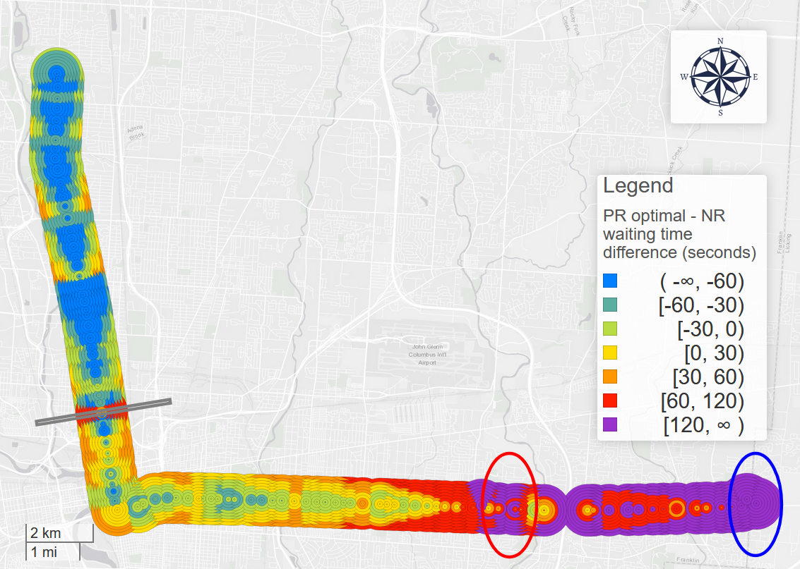

Figure PR optimal – NR waiting time difference (right) for each stop and walking time in COTA bus route No. 2 from Southeast to Northwest in 2018.

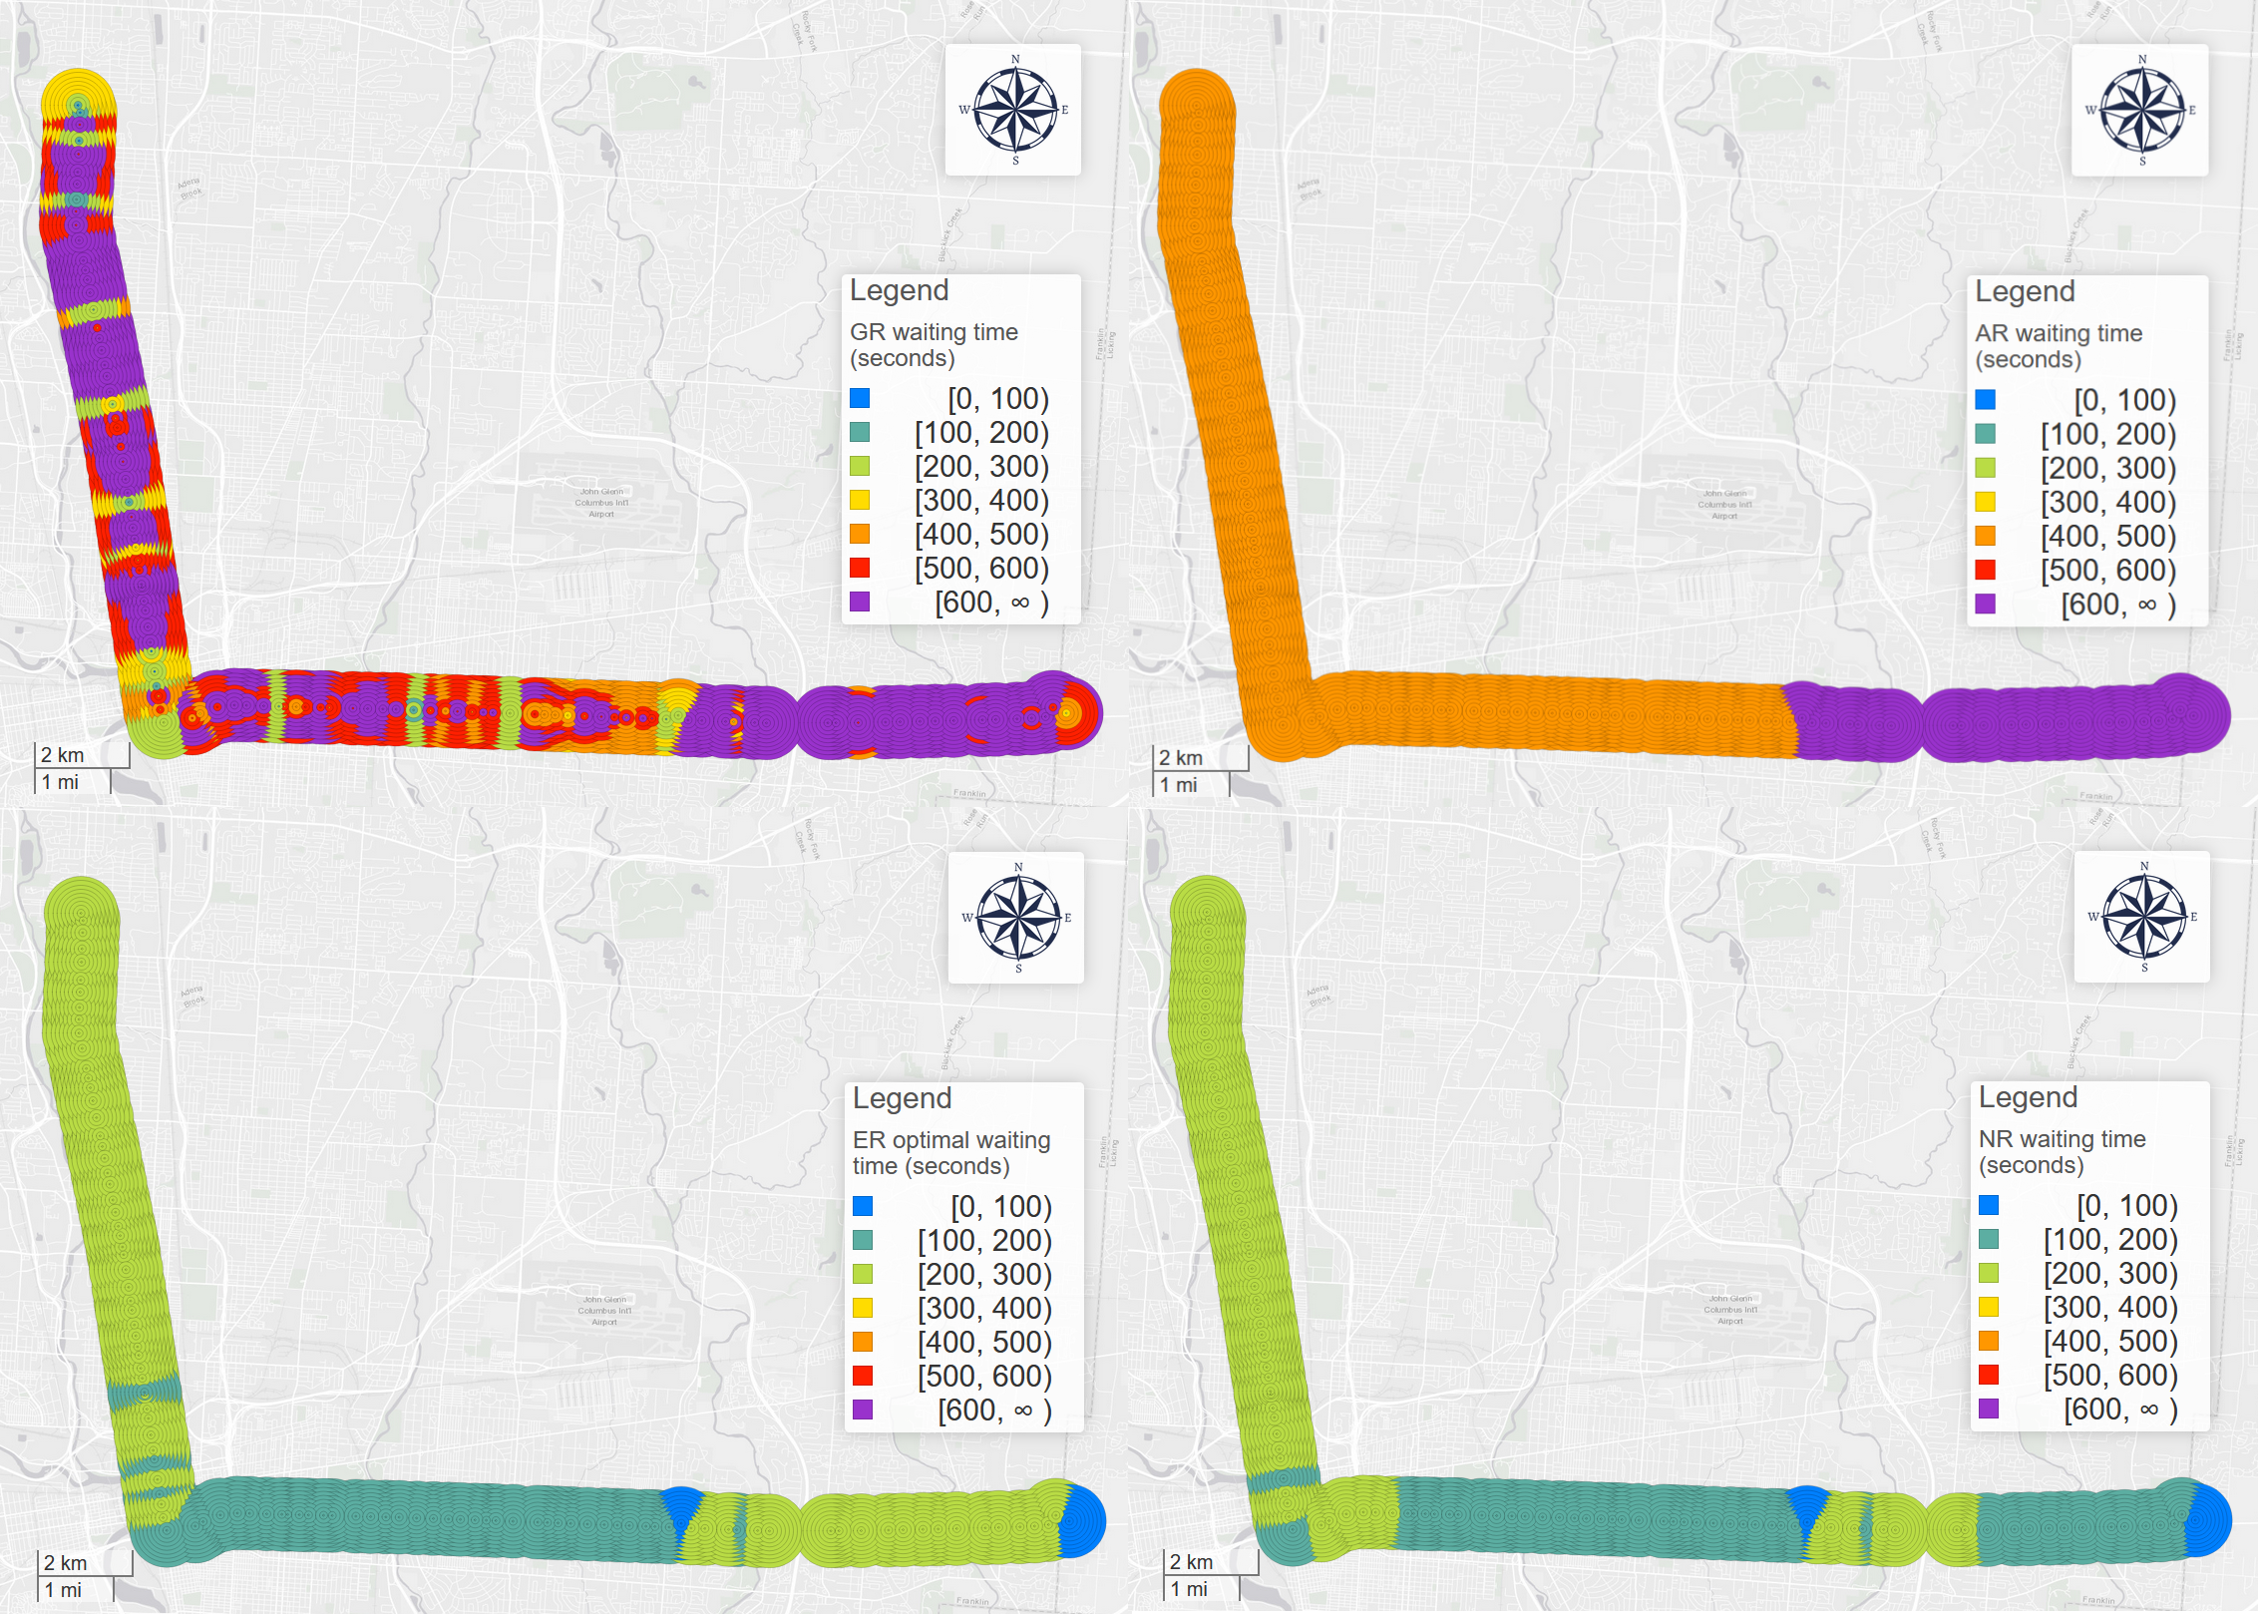

Figure 14 GR (top left), AR (top right), ER (bottom left), NR (bottom right)'s waiting time pattern

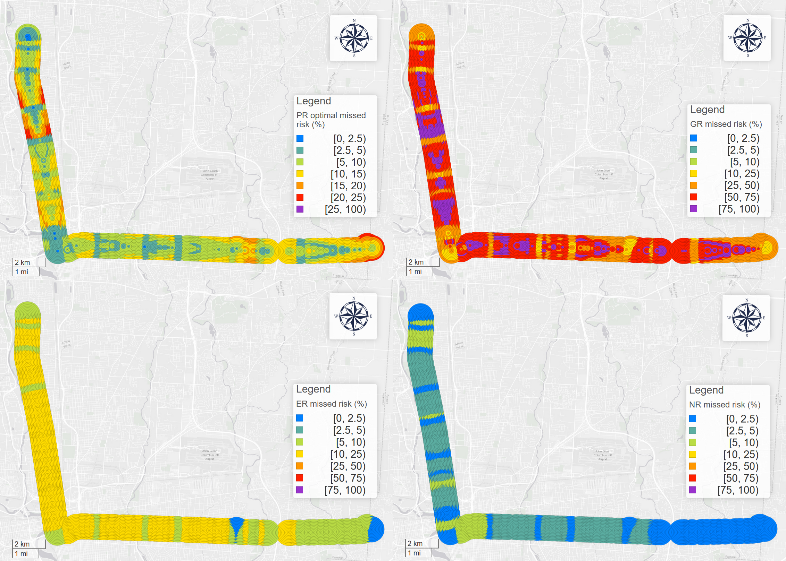

Figure 15 PR optimal (top left), GR (top right), ER with memory (bottom left), NR (bottom right)'s missed risk pattern

* 1. Temporal patterns

In this section, we conducted several temporal analyses based on different resolutions.

**Day of week.** Figure 16 visualizes each TPS’s waiting time on each day of week. For non-NR TPSs, they share similar changing patterns: Weekends have the highest average waiting time, and Wednesday and Thursday are the lowest days; the reason is that the headways of the weekends are much higher and schedules in the weekends are independent from weekdays. However, for NR, Monday is the lowest and Sunday is the highest day.

Figure 16 Each TPS's waiting time on each day of week.

Figure Each TPS's missed risk on each day of week.

**Hour.** We also analyzed the hourly patterns for each TPS. Figure 18 visualized the hourly average waiting time for ER, AR, GR, PR optimal, and NR. For high headway hours like 4:00 to 7:00 and 21:00 to 24:00, ER, AR, GR, and PR optimal all have higher waiting time, since the price of missing a bus will dramatically increase. Although the overall performance of the system during these hours is better than normal hours, on the contrary, users using these TPSs will not benefit but will suffer from buses’ large headway. This also suggests that delay is not the only and absolute standard to assess a system’s performance, instead, the user’s experience is more important. This is especially true in the context of real-time transit apps.

Like the global average waiting time, for most hours, the sequence is GR > AR > ER > PR optimal ≈ NR. However, there are several exceptions, especially for PR optimal and NR: for high headway hours in the morning and midnight, PR optimal’s performance is worse than NR’s; while for most of a day, PR optimal’s performance is better than NR’s. This also suggests that PR optimal is more sensitive to the headway variation.

Figure 18 Each TPS’s hourly average waiting time.

Figure 19 Each TPS's hourly missed risk.

1. Conclusion

Real-time information (RTI) and transit RTI apps can significantly decrease transit users’ waiting time (Brakewood & Watkins, 2018). However, few studies systematically investigated waiting time reduction’s spatiotemporal patterns and optimized the system performance from users’ perspective. In this study, using GTFS real-time data, we first introduce the concept of trip planning strategy (TPS) and five types of TPS for both RTI and non-RTI users. Then, we optimize RTA users’ *prudent relaxation* TPS with optimal insurance buffer. Based on different TPSs’ performance, we calculate the waiting time difference between different TPSs and conduct geographic and temporal analysis in different directions and resolutions. The analyses results show that PR optimal users in upstream stops will wait much more time than the delay, and PR optimal users in this area may suffer from larger missed risk than NR users. It shows that RTI apps using PR TPSs cannot achieve global optimality. Moreover, GR TPS’s performance is the worst among all TPSs despite it is RTI-based. GR’s performance is even worse than the arbitrary relaxation. This moreover suggests that RTI apps could make users’ waiting time significantly longer if apps are not using the appropriate trip planning strategy.

The empirical results and the volunteered optimization system can provide vital information for transit users, planners, and real-time transit app providers. With more access to real-time data, transit system planning should not only engage with the schedule but also real-time performance; RTI apps development should not only engage with real-time performance but also empirical performance; passengers’ trip planning should not only engage with empirical performance but also all the information above. To achieve these three goals, future RTI apps should be able to combine schedule, real-time, and empirical information into one holistic information, with corresponding computation and networking support.

There are still numerous potentials in both future academic and industry area. For example, to improve accuracy and reliability of the public systems and the RTI apps, transit authority or RTI apps providers can add pre-calculated insurance buffers to GTFS data so that RTI apps’ trip planning results inflect PT system’s empirical performance. Meanwhile, the optimization of PR TPS is not fully explored, as there are unlimited numbers of methods to find the best insurance buffer. Unlike simple non-RTI TPSs that , RTI-based TPSs’ calculation processes can be finished by the backend of the RTI apps, in which more complicated and effective algorithms can be applied. For example, with all the abundant auto-generated data, machine learning and neural network should be able to outperform traditional predicting algorithms.

Moreover, although individual passenger’s performance is systematically discussed in this paper, we do not investigate or simulate the proportions of each user group, as Jolliffe and Hutchinson and Bowman and Turnquist contribute to the classification of three classes of passengers (Bowman & Turnquist, 1981; Jolliffe & Hutchinson, 1975). Future research may survey the different user group or the apps provides may disclose statistics of their users, so that RTI apps’ collective impact on the whole population could be calculated.

Reference:

Algers, S., Hansen, S., & Tegner, G. (1975). Role of waiting time, comfort, and convenience in modal choice for work trip. *Transportation Research Record*, *534*, 38–51.

Bowman, L. A., & Turnquist, M. A. (1981). Service frequency, schedule reliability and passenger wait times at transit stops. *Transportation Research Part A: General*, *15*(6), 465–471.

Brakewood, C., Barbeau, S., & Watkins, K. (2014). An experiment evaluating the impacts of real-time transit information on bus riders in Tampa, Florida. *Transportation Research Part A: Policy and Practice*, *69*, 409–422.

Brakewood, C., Macfarlane, G. S., & Watkins, K. (2015). The impact of real-time information on bus ridership in New York City. *Transportation Research Part C: Emerging Technologies*, *53*, 59–75.

Brakewood, C., & Watkins, K. (2018). A literature review of the passenger benefits of real-time transit information. *Transport Reviews*, 1–30.

Cats, O., & Gkioulou, Z. (2017). Modeling the impacts of public transport reliability and travel information on passengers’ waiting-time uncertainty. *EURO Journal on Transportation and Logistics*, *6*(3), 247–270.

Chow, W., Block-Schachter, D., & Hickey, S. (2014). Impacts of real-time passenger information signs in rail stations at the Massachusetts Bay Transportation Authority. *Transportation Research Record*, *2419*(1), 1–10.

COTA. (2019). 2 N HIGH / E MAIN.

Dziekan, K., & Vermeulen, A. (2006). Psychological effects of and design preferences for real-time information displays. *Journal of Public Transportation*, *9*(1), 1.

Fan, Y., Guthrie, A., & Levinson, D. (2016). Waiting time perceptions at transit stops and stations: Effects of basic amenities, gender, and security. *Transportation Research Part A: Policy and Practice*, *88*, 251–264.

Ferris, B., Watkins, K., & Borning, A. (2010). OneBusAway: results from providing real-time arrival information for public transit. In *Proceedings of the SIGCHI Conference on Human Factors in Computing Systems* (pp. 1807–1816). ACM.

Fonzone, A., Schmöcker, J.-D., & Liu, R. (2015). A model of bus bunching under reliability-based passenger arrival patterns. *Transportation Research Procedia*, *7*, 276–299.

Fries, R. N., Dunning, A. E., & Chowdhury, M. A. (2011). University traveler value of potential real-time transit information. *Journal of Public Transportation*, *14*(2), 2.

Frumin, M., & Zhao, J. (2012). Analyzing passenger incidence behavior in heterogeneous transit services using smartcard data and schedule-based assignment. *Transportation Research Record*, *2274*(1), 52–60.

Gkioulou, Z. (2013). Evaluating the impact of waiting time uncertainty on passengers´ decisions.

Google Developers. (2016). GTFS Static Overview | Static Transit | Google Developers. Retrieved March 8, 2018, from https://developers.google.com/transit/gtfs/

Google Developers. (2018). Trip Updates. Retrieved April 8, 2019, from https://developers.google.com/transit/gtfs-realtime/guides/trip-updates

Goyder, J. (1986). Surveys on surveys: Limitations and potentialities. *Public Opinion Quarterly*, *50*(1), 27–41.

Jolliffe, J. K., & Hutchinson, T. P. (1975). A behavioural explanation of the association between bus and passenger arrivals at a bus stop. *Transportation Science*, *9*(3), 248–282.

Larsen, O. I., & Sunde, Ø. (2008). Waiting time and the role and value of information in scheduled transport. *Research in Transportation Economics*, *23*(1), 41–52.

Liu, Y., Shi, J., & Jian, M. (2017). Understanding visitors’ responses to intelligent transportation system in a tourist city with a mixed ranked logit model. *Journal of Advanced Transportation*, *2017*.

Neuman, W. L., & Robson, K. (2014). *Basics of social research*. Pearson Canada Toronto.

Papangelis, K., Nelson, J. D., Sripada, S., & Beecroft, M. (2016). The effects of mobile real-time information on rural passengers. *Transportation Planning and Technology*, *39*(1), 97–114.

Park, Y., Mount, J., Liu, L., Xiao, N., & Miller, H. J. (2019). Assessing public transit performance using real-time data: spatiotemporal patterns of bus operation delays in Columbus, Ohio, USA. *International Journal of Geographical Information Science*, 1–26.

Reed, T. B. (1995). Reduction in the burden of waiting for public transit due to real-time schedule information: a conjoint analysis study. In *Pacific Rim TransTech Conference. 1995 Vehicle Navigation and Information Systems Conference Proceedings. 6th International VNIS. A Ride into the Future* (pp. 83–89). IEEE.

Rossi, P. H., Wright, J. D., & Anderson, A. B. (2013). *Handbook of survey research*. Academic Press.

Transit app. (2019). How we shrank our trip planner till it didn’t need data. Introducing public transit’s fastest, tiniest, offline-capable trip planner. Retrieved December 5, 2019, from https://medium.com/transit-app/how-we-shrank-our-trip-planner-till-it-didnt-need-data-84984ca56663

Watkins, K. E., Ferris, B., Borning, A., Rutherford, G. S., & Layton, D. (2011). Where Is My Bus? Impact of mobile real-time information on the perceived and actual wait time of transit riders. *Transportation Research Part A: Policy and Practice*, *45*(8), 839–848.

Wright, K. B. (2005). Researching Internet-based populations: Advantages and disadvantages of online survey research, online questionnaire authoring software packages, and web survey services. *Journal of Computer-Mediated Communication*, *10*(3), JCMC1034.